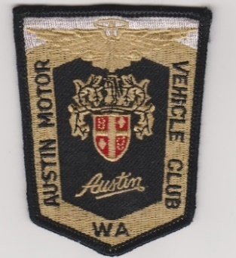
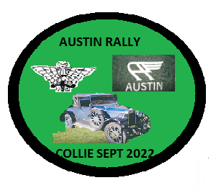

AUSTIN MOTOR VEHICLE CLUB OF
WESTERN AUSTRALIA
and the COLLIE BRANCH of VCC WA

[Sidebar Title]
[Sidebars are great for calling out important points from your text or adding additional info for quick reference, such as a schedule.
They are typically placed on the left, right, top or bottom of the page. But you can easily drag them to any position you prefer.
When you’re ready to add your content, just click here and start typing.]

[Sidebar Title]
[Sidebars are great for calling out important points from your text or adding additional info for quick reference, such as a schedule.
They are typically placed on the left, right, top or bottom of the page. But you can easily drag them to any position you prefer.
When you’re ready to add your content, just click here and start typing.]

COLLIE WEEKEND RALLY
2nd to 5th September 2022
ENTRY FORM
Please complete the form below and email it to
Jeff and Alvera Gibbs: froggyville34@bigpond.com
Eric and Kerry Martin: martin771@bigpond.com
Hamish and Dot Pipe: hrdp@bigpond.com

Name:

Address

Email

Phone(H) Mobile

Number of people Passenger name

Car Club

I intend on entering the following vehicles:
Make Model Year Rego Number

DECLARATION
The Austin Motor Vehicle Club of WA Inc, The Collie Branch of the VCC , the club’s committee, co-ordinators, agents and other associated clubs and organisations will in no way be held responsible for any loss of life, injury or damage suffered by or to any vehicle, entrant, owner, driver or passenger or to any other person/s or property through any unforeseen circumstances.
NB. By submitting this form to the Austin Motor Vehicle Club of WA or the Collie Branch of the VCC the persons named above acknowledge, agree with, and will abide by the above stated declaration.

Signed ……………………………………………………………Dated ……………………………

